REPORT – Assignment 7 (jQuery)
Student: Adilbek Arman
Group: SE-2432
Objective:
To learn and apply jQuery for DOM manipulation, event handling, visual effects, and animations.
Task 1 – Selectors & CSS
Task Description:
In this task, you need to learn how to use jQuery selectors and basic style manipulation.
- Include the jQuery library from a CDN inside your HTML file.
- Create several elements on the page — one with an id, one with a class, and one simple <p> tag.
- Use jQuery selectors to access each of these elements.
- Change their text and HTML content using .text() and .html() methods.
- Modify their styles dynamically using the .css() method (for example, change text color or font size).
- Add a button that triggers all these actions when clicked.
Goal:
To understand how to select, modify, and style elements dynamically using jQuery.
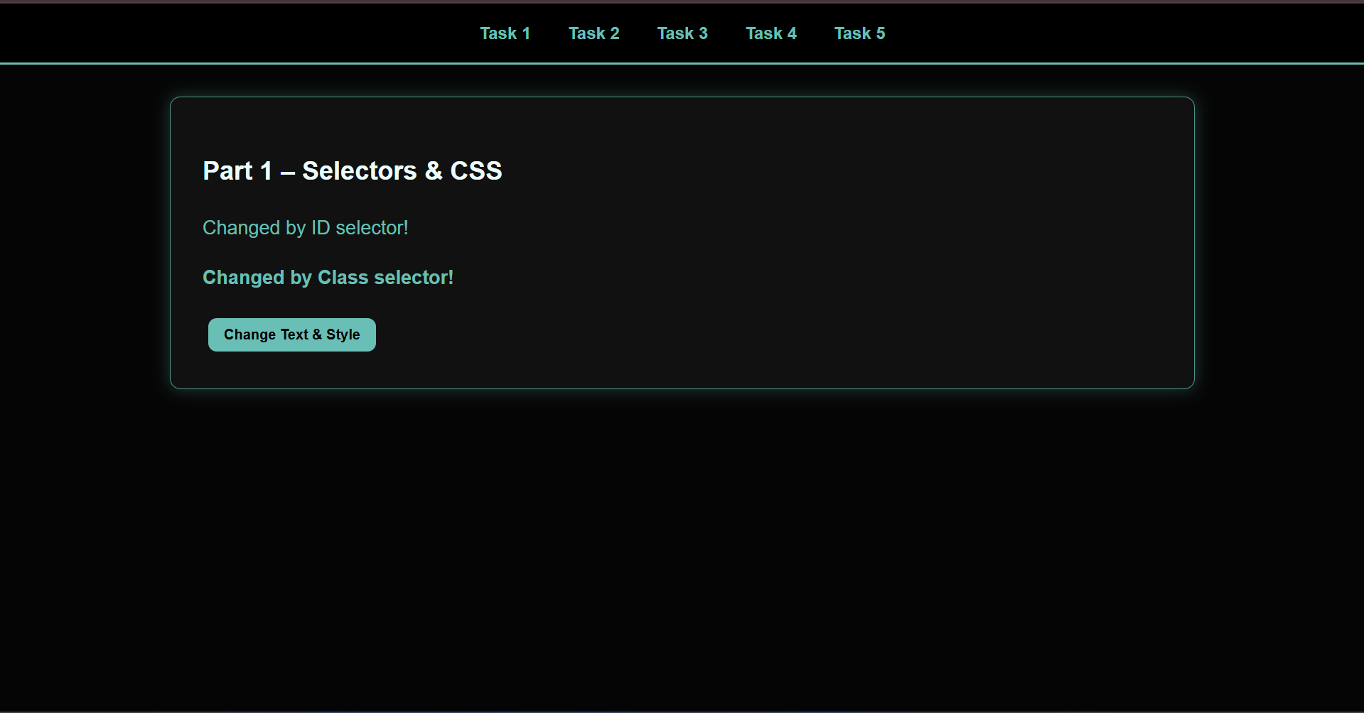

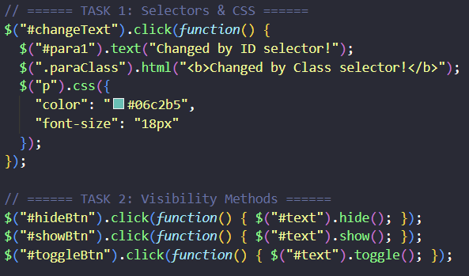
Task 2 – Effects
Task Description:
This part focuses on creating interactive visual effects using jQuery.
- Create a paragraph and add three buttons: Hide, Show, and Toggle.
  - Use .hide(), .show(), and .toggle() methods to control the visibility of the paragraph.
- Add an image to the page and create buttons for Fade In, Fade Out, and Fade Toggle effects.
  - Use .fadeIn(), .fadeOut(), and .fadeToggle() methods to smoothly change image opacity.
- Create a collapsible panel with text and a button to open/close it using .slideUp(), .slideDown(), and .slideToggle().
Goal:
To explore jQuery’s built-in animation and visibility methods for creating smooth interactive effects.
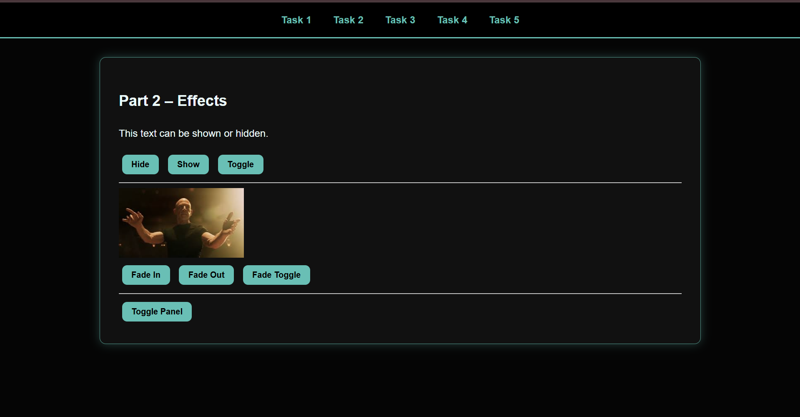
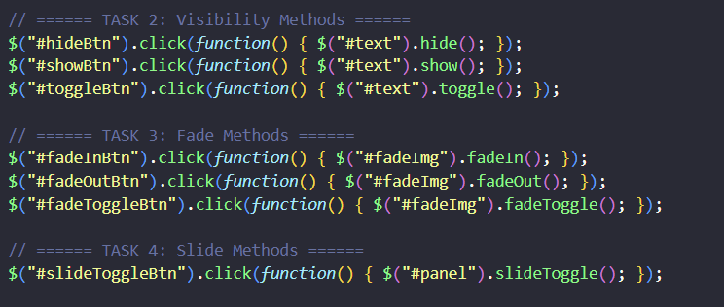
Task 3 – DOM Manipulation
Task Description:
This task is about working with the page structure dynamically using jQuery methods.
- Create an unordered list (<ul>) and two buttons: Add Item and Remove Item.
  - Use .append() or .prepend() to add new list items, and .remove() to delete them.
- Add an image and a hyperlink to the page.
  - Use .attr() to change the image’s src and the link’s href when buttons are clicked.
- Create a small form with Name and Email input fields.
  - Display the input values live below the form using .val() and .text() so that as the user types, the output updates in real time.
Goal:
To learn how to dynamically add, remove, and modify elements and attributes in the DOM with jQuery.
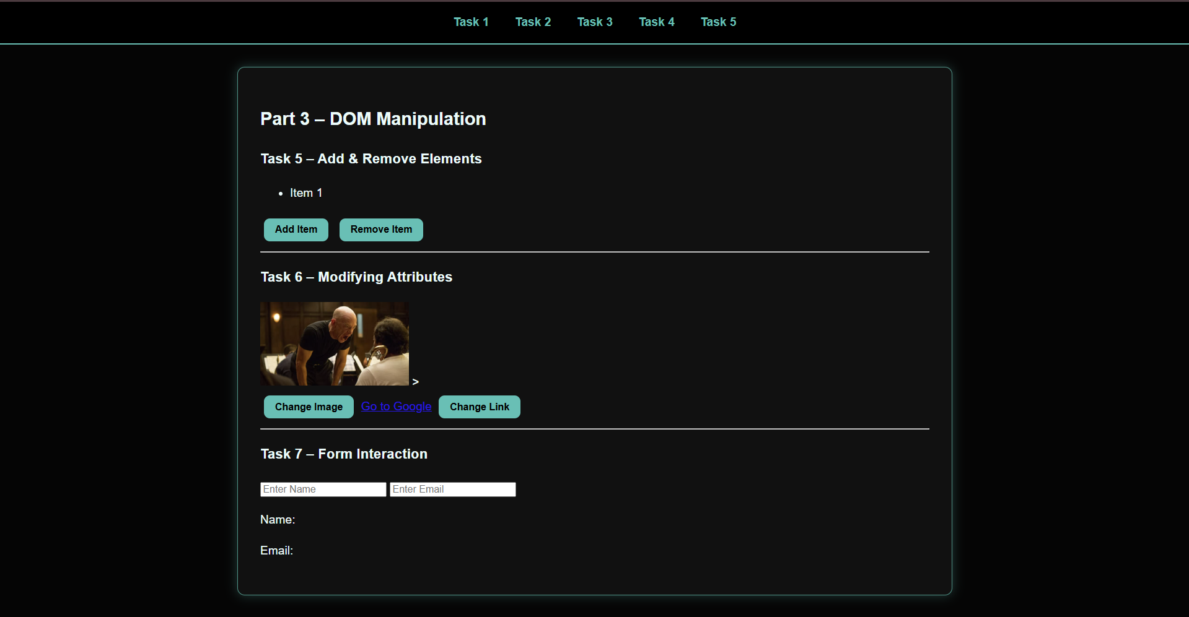
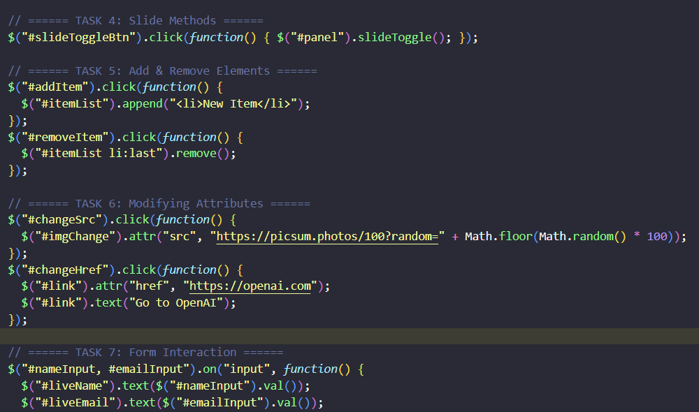
Task 4 – Animations
Task Description:
This part teaches how to use jQuery’s .animate() method to create animations.
- Create a square <div> block that can move and resize on the screen.
- Add three buttons:
  - Basic Animation – Increase the box’s size and move it slightly using .animate().
  - Sequential Animation – Move the box step-by-step (right → down → shrink → return to original position).
  - Combined Animation – Change size, opacity, and position all in one .animate() call.
Goal:
To understand how to animate HTML elements smoothly using jQuery’s animation functions.
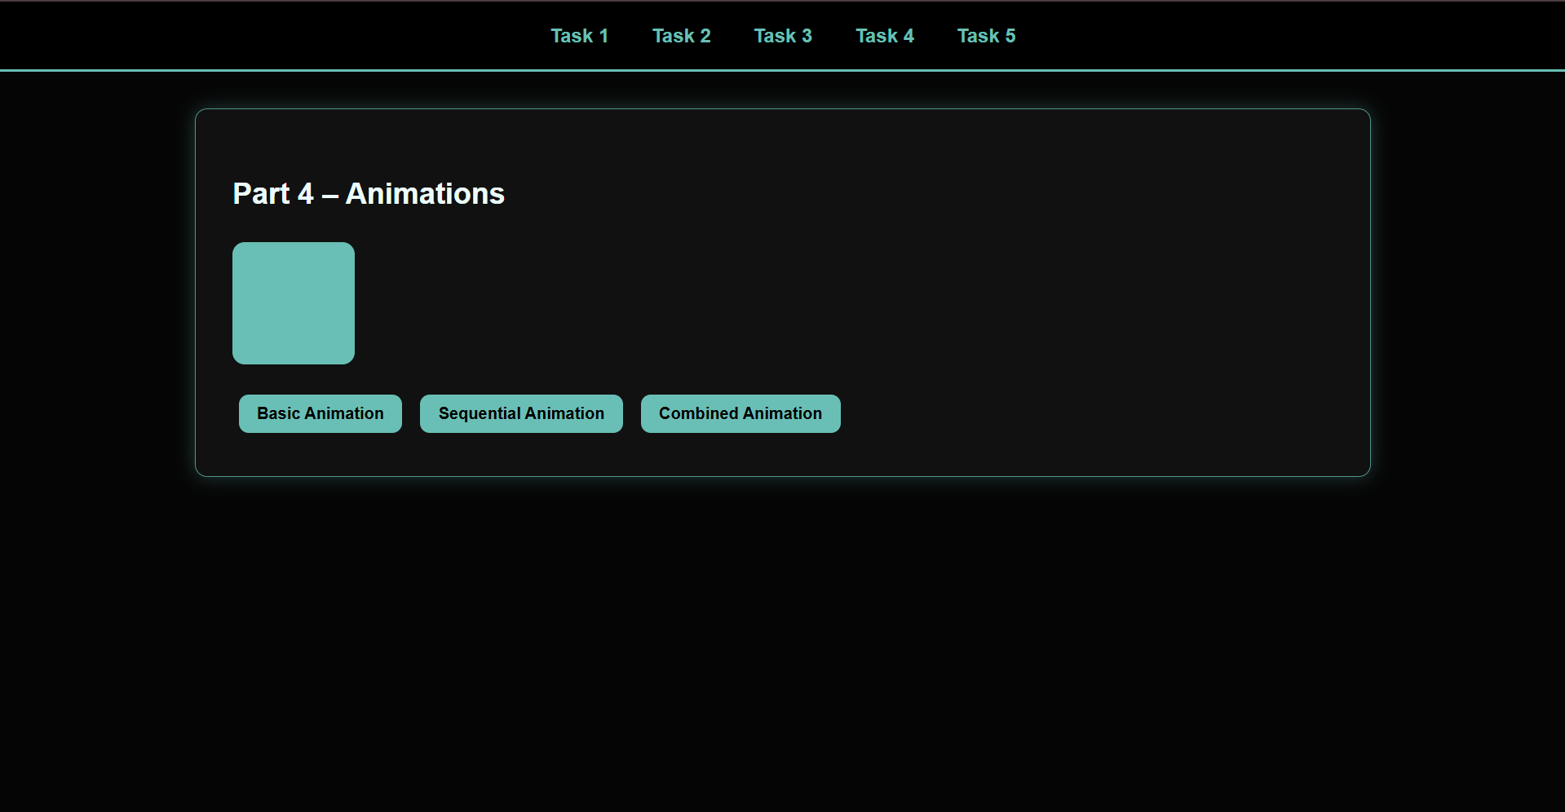
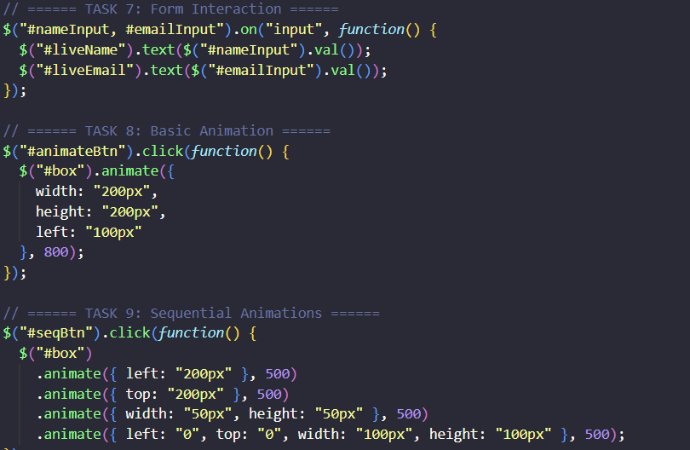
Task 5 – Mini Project: Image Gallery
Task Description:
In the final task, you will create a small interactive gallery using jQuery effects.
- Add several image thumbnails of equal size (use object-fit: cover in CSS for consistent sizing).
- When a thumbnail is clicked, display the selected image as a larger version below or in the center using a fade-in effect.
- Use .fadeIn() or .fadeToggle() for the main image transition.
- Style the gallery with borders, hover effects, and smooth transitions.
Goal:
To combine all learned skills (selectors, effects, and animations) to create an interactive and visually appealing mini project.
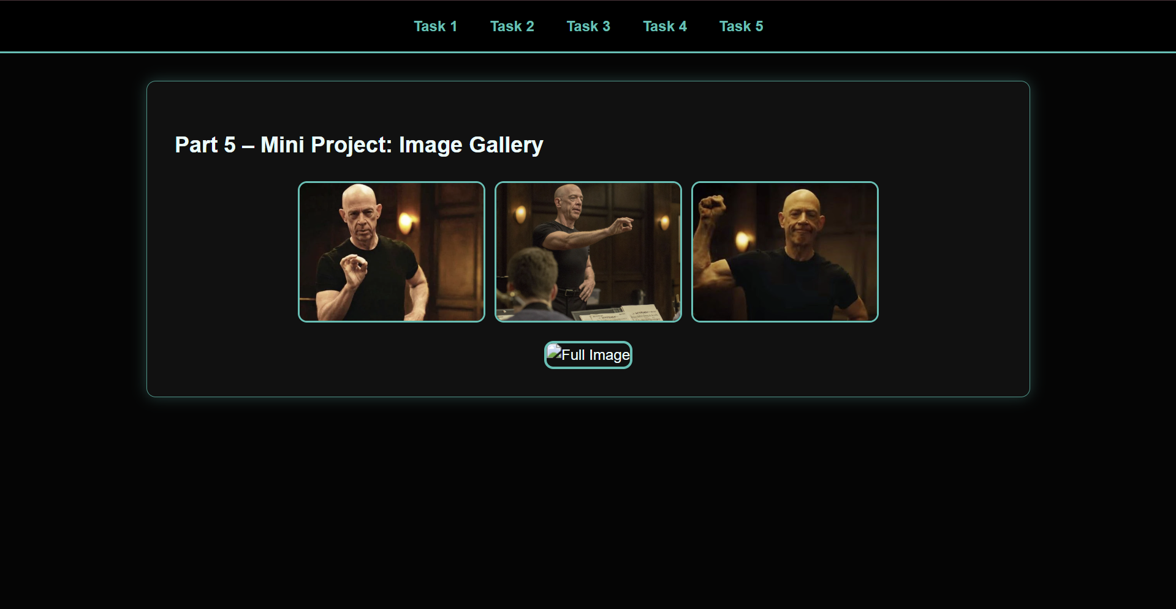
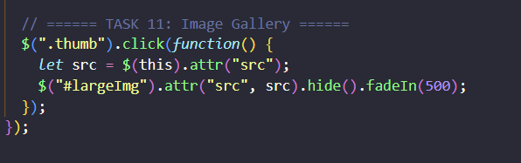
Conclusion
In this assignment, I learned how to use jQuery to make websites more dynamic, interactive, and visually appealing.
Through each task, I practiced selecting and manipulating HTML elements, applying different effects, and creating smooth animations. I also learned how to change element attributes, work with forms in real time, and control the Document Object Model (DOM) efficiently.
By completing the final mini project (Image Gallery), I combined all the learned techniques — selectors, effects, and animations — into a single interactive project that demonstrates how jQuery can improve user experience on a web page.
Overall, this assignment helped me strengthen my understanding of front-end development concepts, improve my JavaScript skills, and gain practical experience with one of the most widely used JavaScript libraries in web development.

